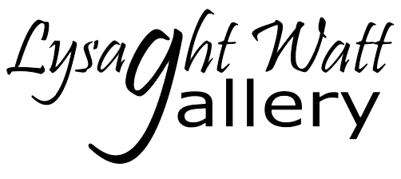
4-6 Union Street, Hāwera 4610
PO Box 362, Hāwera 4640
Ph: 06 278 7611
secretary.lwg1@gmail.com
www.lysaghtwattgallery.co.nz

BECOME A FRIEND OF
LYSAGHT WATT GALLERY/ STAGE INC.
Name:.......................................................................... Phone: ......................................
Address:.............................................................................................................................
.................................................................................... Postcode: ....................................
Email: ................................................................................................................................
Signature:.................................................................... Date: ...........................................
Subscription for year - $10 per person – donations greatly received
Payment options:
□ Online banking to our account (STAGE Inc.) - 15 3950 05812600 00, TSB Bank, Hāwera (Please include your first and surname as reference, then post, email or deliver this form so we can retain your membership information)
□ At the Gallery, by EFTPOS or cash – receipt no:....................................
Date: .............................................................
□ By post to the Secretary, PO Box 362, Hāwera 4640

General Information:
Are you an artist? □ Yes □ No
Are you interested in becoming a
Volunteer □ Yes □ No
Paid by □ Cash □ Eftpos □ Online
Membership Use: □ Database □ Newsletter □ Volunteer List
□ Card
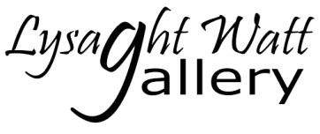

THANK YOU FOR YOUR SUPPORT!
By becoming a Friend of the Gallery, you are supporting the Lysaght Watt Gallery to:
- Establish a high profile gallery in Hāwera and support the initiatives of other art groups within the South Taranaki District with the provision of exhibition spaces.
- Facilitate economic development opportunities for the arts in South Taranaki.
- Provide opportunities for creative expression and artistic celebration by interaction between artists and the community.
- Increase access to expertise and education in the field of the arts.
As a Friend you will receive our monthly digital newsletter, invitations to our exhibition openings and the Annual Art Award plus the opportunity to talk with the artists. You will also receive a Friend’s only discount on art supplies at Hāwera Paper Plus.
The Gallery is operated by the South Taranaki Art Gallery and Exhibitions Inc. (STAGE Inc.) which is registered as a charitable organisation. All persons involved in the operation of the Gallery are volunteers. STAGE Inc. relies on donations, subscriptions, grants and commission on sales to cover our operating costs. We are grateful to the South Taranaki District Council, Lysaght Watt Trust and Creative Communities for their ongoing support.
For further enquiries:
- please phone the Gallery – 06 278 7611
- visit the Gallery – 4-6 Union Street, Hāwera
- email secretary.lwg1@gmail.com
- visit our website www.lysaghtwattgallery.co.nz
- please like us on Facebook too! www.facebook.com/LWArtGallery

